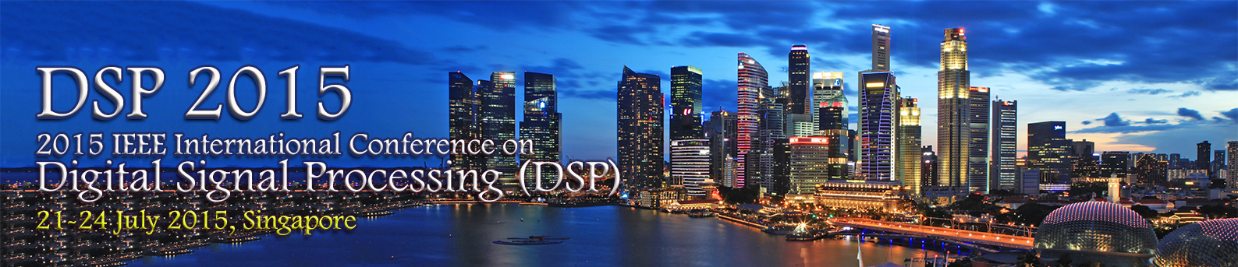

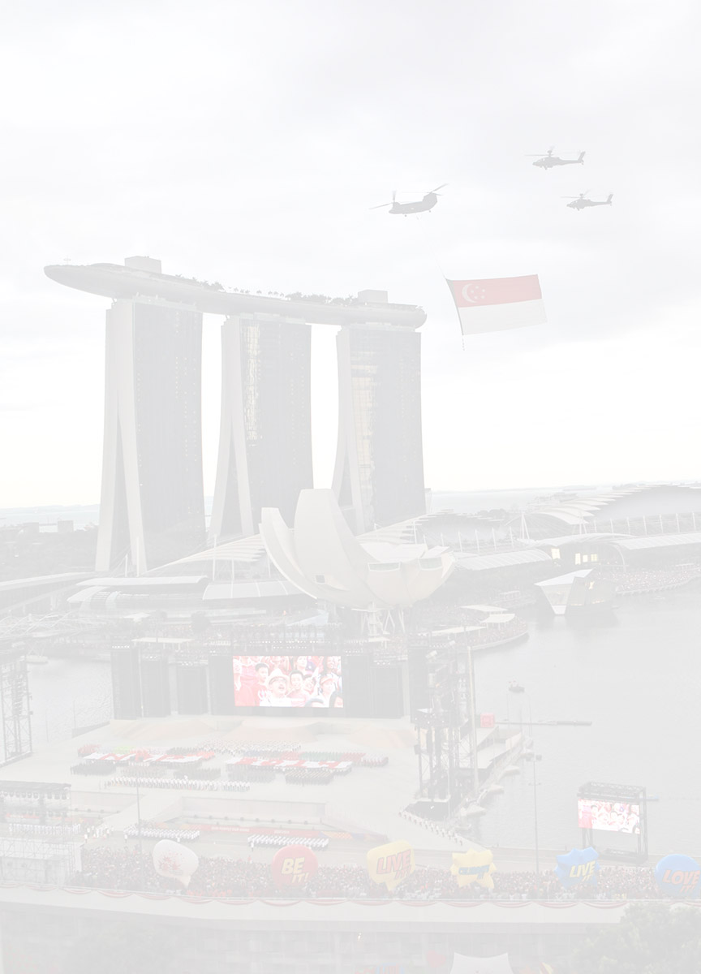

2015 IEEE International Conference on Digital Signal Processing (DSP), initiated by Imperial College, London, and organized by IEEE Circuits and Systems Society Singapore Chapter, will be held in July 21-24, 2015 in Singapore. It is the longest in existence Conference in the area of DSP and belongs to a series of events, which commenced in London in 1968 and continued to Florence, Nicosia, Limassol, Santorini, Cardiff, Corfu, etc. The latest meeting took place in Hong Kong, SAR, P. R. China in August 2014.

DSP 2015 addresses the theory and application of filtering, coding, transmitting, estimating, detecting, analysing, recognising, synthesising, recording, and reproducing signals by means of digital devices or techniques. The term "signal" includes audio, video, speech, image, communication, geophysical, sonar, radar, medical, musical, and other signals.

**Indicative topics of interest:**

|  |  |
| --- | --- |
| **Biomedical Signal Processing**   * Biomedical Signal and Image Processing * Brain-Computer Interface * Genomic Signal Processing * Signal Processing in Genomics and Proteomics   **Digital and Multirate Signal Processing**   * Adaptive Signal Processing * Digital and Multirate Signal Processing * Digital Filter Design and Implementation * Multidimensional Filters and Transforms * Multiresolution Signal Processing * Multiway Signal Processing * Theory and Applications of Transforms * Time-Frequency Analysis and Representation * Statistical Signal Processing   **Sensor Array and Multichannel Processing**   * Array Signal Processing * Signal Processing for Smart Sensors and Systems * Compressive Sensing   **Signal Processing for Communications**   * Geophysical/Radar/Sonar Signal Processing * MIMO Signal Processing | **Signal Processing for Audio/Image/Video**   * Audio/Speech/Music Processing & Coding * Digital Photography * HDR Imaging * Image and Multidimensional Signal Processing * Image/Video Indexing, Search and Retrieval * Image/Video Compression and Coding Standards * Image/Video Content Analysis * Image/Video Processing Techniques * 3D Image Processing and Applications * Mobile Imaging and Image Quality * Real-Time Signal/Image/Video Processing * Video Surveillance and Transportation Imaging * Digital Watermarking and Data Hiding   **Other Areas and Applications**   * Big Data * Cognitive Signal Processing * DSP Education * Nonlinear Signals and Systems * Information Forensics and Security * Internet of Things (IoT) * Social Signal Processing & Affective Computing * Signal and System Modelling * Signal Processing of Financial Data * VLSI Architectures and Implementations for DSP |

The language of the Conference is English. Prospective authors are invited to electronically submit the full camera-ready paper. The paper must not exceed four (4) pages plus one (1) page references and should be written in English. Authors should indicate one or more of the above listed categories that best describe the topic of the paper, as well as their preference (if any) regarding lecture or poster sessions. Lecture and poster sessions will be treated equally in terms of the review process. Submitted papers will be peer-reviewed by experts in the field. **All accepted and presented papers** will be included in the Conference Proceedings and **will be available on IEEE Xplore and EI Compendex.** **There will be best paper awards.**

In addition to the technical program, a social program will be offered to the participants and their companions. It will provide an opportunity to meet colleagues and friends against a backdrop of outstanding natural beauty and rich cultural heritage in one of the best known international tourist destinations.

**Important Deadlines**

Submission of Special Session Proposal : Feb 9, 2015 **Submission of full papers :  Feb 16, 2015**Submission of Special Session papers : March 2, 2015  **Notification of acceptance :  Before April 13, 2015\***Submission of final papers :  May 4, 2015   
Author Registration : May 4, 2015  
Conference :  July 21-24, 2015

*\*Papers will be sent for review soon after submission. A decision will be made once it is possible to do so. Authors who submit early may receive decisions early.*

**Honorary Chair**  
CONSTANTINIDES, Anthony George,  
*Imperial College, London, UK*

**General Co-Chairs**CHAU, Lap Pui   
*Nanyang Technological Uni., Singapore*  
LIM, Yong Ching  
*Nanyang Technological Uni., Singapore*MANDIC, Danilo  
*Imperial College, UK*  
SIU, Wan Chi  
*Hong Kong Polytechnic Uni., HK*   
TAN, Tieniu  
*Chinese Academy of Sciences, PRC*

**Constantinides Track Chair**SARAMÄKI, Tapio  
*Tampere Uni. of Technology, Finland*

**Cherry Track Chair**DINIZ, Paulo Sergio Ramirez  
*Uni. Federal do Rio de Janeiro, Brazil*

**Gabor Track Chair**CHAKRABORTY, Mrityunjoy  
*Indian Institute of Tech. Kharagpur, India*

**Technical Program Co-Chairs**CHAMBERS, Jonathon  
*University of Surrey, UK*  
KWAN, Hon Keung  
*University of Windsor, Canada*  
LEUNG, King K  
*Imperial College, UK*  
LIAN, Yong  
*National Uni. of Singapore, Singapore*  
LUN, Pak-Kong  
*Hong Kong Polytechnic Uni., HK*  
YU, Yajun  
*Nanyang Technological Uni., Singapore*

**Europe Liaison Chair**GABBOUJ, Moncef  
*Tampere Uni. of Technology, Finland*

**North America Liaison Chair**ZHU, Wei-Ping  
*Concordia University, Canada*

**South America Liaison Chair**DA SILVA, Eduardo A. B.   
*Uni. Federal do Rio de Janeiro, Brazil*

**Publicity Co-Chairs**KOT, Alex Chichung   
*Nanyang Technological Uni., Singapore*   
LIN, Zhiping  
*Nanyang Technological Uni., Singapore*

**Special session Chair**LEE, Jun Wei  
*Temasek Laboratories - NTU, Singapore*

**Publication Co-Chairs**HA, Yajun  
*I2R, A*STAR, Singapore*ZHOU, Jun   
*IME, A*STAR, Singapore*

**Finance Chair**WANG, Yi  
*I2R, A*STAR, Singapore*

**Local Arrangement Co-Chairs**CHONG, Kwen Siong   
*Nanyang Technological Uni., Singapore*  
GWEE, Bah Hwee   
*Nanyang Technological Uni., Singapore*  
MA, Fan-Yung  
*Infineon Technologies, Singapore*

**Local Sponsorship Chair**

FOO, Say Wei,

*Nanyang Technological Uni., Singapore*

**Electronic Media Chair**KHONG, Andy W. H.   
*Nanyang Technological Uni., Singapore*

  

The 2015 20th International Conference on Digital Signal Processing (DSP 2015), initiated by Imperial College, London, and organized by IEEE Circuits and Systems Singapore Chapter, will be held in July 21-24, 2014 in Singapore. It is the longest in existence Conference in the area of DSP and belongs to a series of events, which commenced in London in 1968 and continued to Florence, Nicosia, Limassol, Santorini, Cardiff, Corfu, etc. The latest meeting took place in Hong Kong, SAR, P. R. China in August 2014. DSP 2015 addresses the theory and application of filtering, coding, transmitting, estimating, detecting, analysing, recognising, synthesising, recording, and reproducing signals by means of digital devices or techniques. The term "signal" includes audio, video, speech, image, communication, geophysical, sonar, radar, medical, musical, and other signals.

|  |  |
| --- | --- |
| **Indicative topics of interest:** | |
| **Biomedical Signal Processing**   * Biomedical Signal and Image Processing * Brain-Computer Interface * Genomic Signal Processing * Signal Processing in Genomics and Proteomics   **Digital and Multirate Signal Processing**   * Adaptive Signal Processing * Digital and Multirate Signal Processing * Digital Filter Design and Implementation * Multidimensional Filters and Transforms * Multiresolution Signal Processing * Multiway Signal Processing * Theory and Applications of Transforms * Time-Frequency Analysis and Representation * Statistical Signal Processing   **Sensor Array and Multichannel Processing**   * Array Signal Processing * Signal Processing for Smart Sensors and Systems * Compressive Sensing   **Signal Processing for Communications**   * Geophysical/Radar/Sonar Signal Processing * MIMO Signal Processing | **Signal Processing for Audio/Image/Video**   * Audio/Speech/Music Processing & Coding * Digital Photography * HDR Imaging * Image and Multidimensional Signal Processing * Image/Video Indexing, Search and Retrieval * Image/Video Compression and Coding Standards * Image/Video Content Analysis * Image/Video Processing Techniques * 3D Image Processing and Applications * Mobile Imaging and Image Quality * Real-Time Signal/Image/Video Processing * Video Surveillance and Transportation Imaging * Digital Watermarking and Data Hiding   **Other Areas and Applications**   * Big Data * Cognitive Signal Processing * DSP Education * Nonlinear Signals and Systems * Information Forensics and Security * Internet of Things (IoT) * Social Signal Processing & Affective Computing * Signal and System Modelling * Signal Processing of Financial Data * VLSI Architectures and Implementations for DSP |

The language of the Conference is English. Prospective authors are invited to electronically submit the full camera-ready paper. The paper must not exceed six (6) pages, including figures, tables and references, and should be written in English. Authors should indicate one or more of the above listed categories that best describe the topic of the paper, as well as their preference (if any) regarding lecture or poster sessions. Lecture and poster sessions will be treated equally in terms of the review process. Submitted papers will be peer-reviewed by experts in the field. All accepted and presented papers will be included in the Conference Proceedings and will be available on IEEE Xplore and EI Compendex. In addition to the technical program, a social program will be offered to the participants and their companions. It will provide an opportunity to meet colleagues and friends against a backdrop of outstanding natural beauty and rich cultural heritage in one of the best known international tourist destinations.

**Important Deadlines**  
**Submission of full papers :  Feb 23, 2015   
Submission of Special Session Proposal : Feb 16, 2015   
Submission of Special Session papers : March 16, 2015   
Notification of acceptance :  April 6, 2015   
Submission of camera-ready papers :  April 27, 2015   
Conference :  July 21-24, 2015**